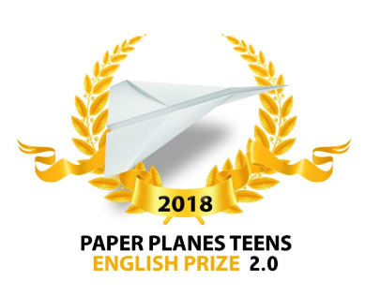
CONGRATULATIONS !
The English teachers of the LFL have selected the following students to participate in the national contest:
COLLEGE
catégorie | Nom | titre
Fiction | Aolo Canelle  Coulon Juliette  Soyier Anaëlle | Canellia’s adventure
 | Tete-B Leya  Agbangbatin Lionnella  Santanna Maya | The truth
 | Cissé Malick | The adventures of Steve and his friends
Poem | Atakpama Juliette | The devastated heart
 | Attebi Rehoboth | My best friend
Non fiction | Li Eric | Eric’s travel to Taiwan

LYCEE
catégorie | Nom | titre
Fiction | Baniab Eva | Beauty beyond size
 | Kapinga Rebecca et Kohy Bath-Cheba | The new girls
 | Goto Selom | Doppelgangers
 | Amadou Véronique | Teens
 | Akemakou Ahmès | Joy
Poem | Zanou Iwen | 4Real
 | Gnassingbé Chiara | Goodbye

- More information on https://www.facebook.com/PaperPlanesTeens/

